Monthly Cost Avoidance Report, March 2021

Now that we’ve got all twelve months of data from the year 2020 it’s time to celebrate! The graph below represents raw utility costs comparing 2020 with 2019. As you can see, the utility costs were lower each month compared to the same time period the year before. In 2020 we lowered our utility bills by $670,028!

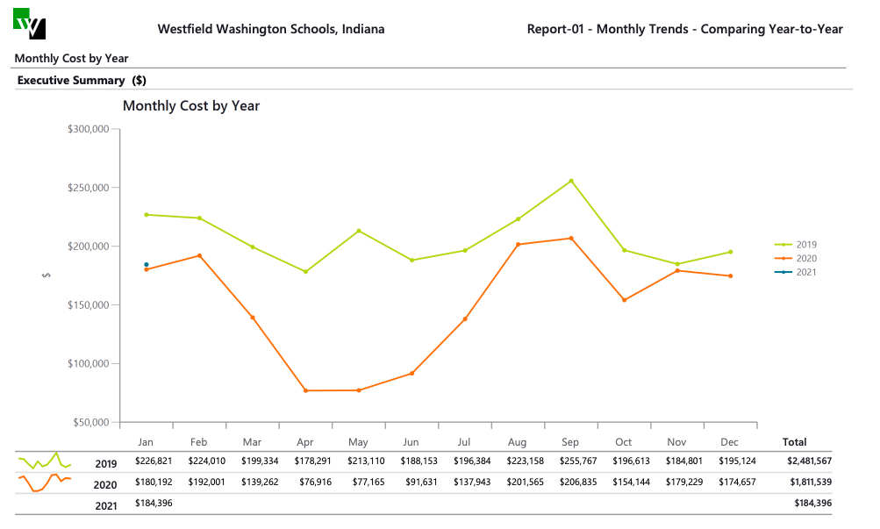
Below is the monthly cost avoidance summary for 2020. As you can see, we set some clear records during the COVID shutdown period.
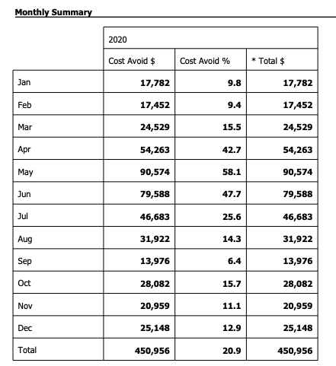

Next, we set our sites on the upcoming Spring Break shutdown. Faculty and staff are getting good at setting back their rooms so simple reminders to that group are needed. The main focus will to be setting back BAS schedules and ensuring that all unused areas are off during the break.

